**System Administrator**

**Survey Configurator App**

Year 2023  
Version 1.00

# Description of the App

## Purpose of the app

The Survey Configurator app is a powerful app designed to empower users to create and customize surveys effortlessly. With it is user-friendly interface and flexible options. By providing a wide range of question types, users can gather valuable feedback from respondents, enabling better decision making and enhancing their understanding of various topics.

# Installation Requirements

To Ensure a seamless setup and management of the app, we require specific software installation on your system. Please review the following installation requirement:

## Dot Net Framework

Please install .Net Framework version 4.5 or above in your system

## SQL Server Management Studio (SSMS)

Install SQL server Management Studio on the system. SSMS is a critical tool for database management.

## SQL Server Configuration Manager

Install SQL Server Configuration Manager, which is used to manage SQL Server services, network settings, and protocols effectively.

# Create The Database

* The "createDatabase" script is located in the data layer of the app directory.

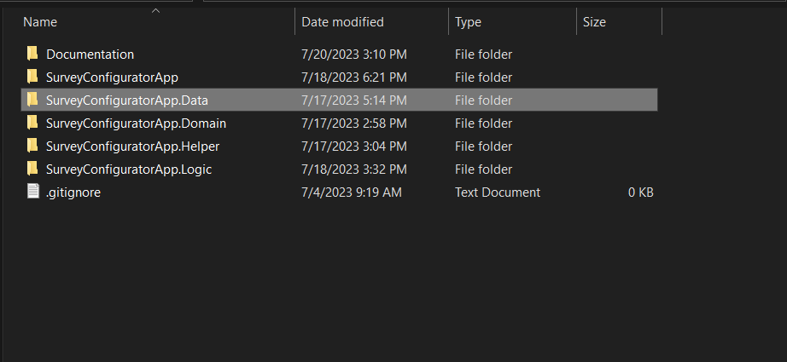

*Fig 1 App Directory*

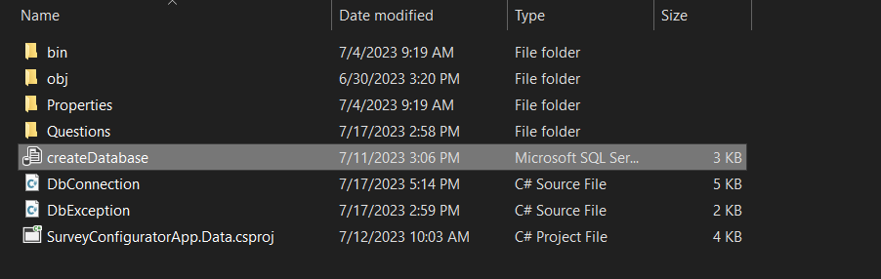

*Fig 2 Data Layer*

* Open SQL Server Management Studio (SSMS) and connect to the appropriate SQL Server.
* Open the "createDatabase.sql" script in SSMS.
* Run the script by clicking the "Execute" or pressing "F5" in SSMS.

# App Configuration

## Changing Connection Configuration in the App

Once you have completed the previous instruction, you can now open the app. Follow the steps below to change the connection configuration:

1. Click on **"Settings",** When you click on the settings you will notice two important things

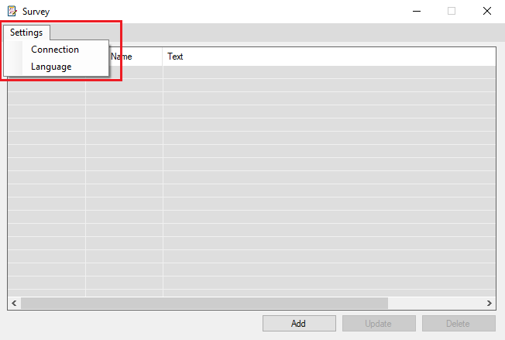

*Fig. 2 Settings*

### Connection: Enter the required connection details, such as server address, username which represent user id, and password.

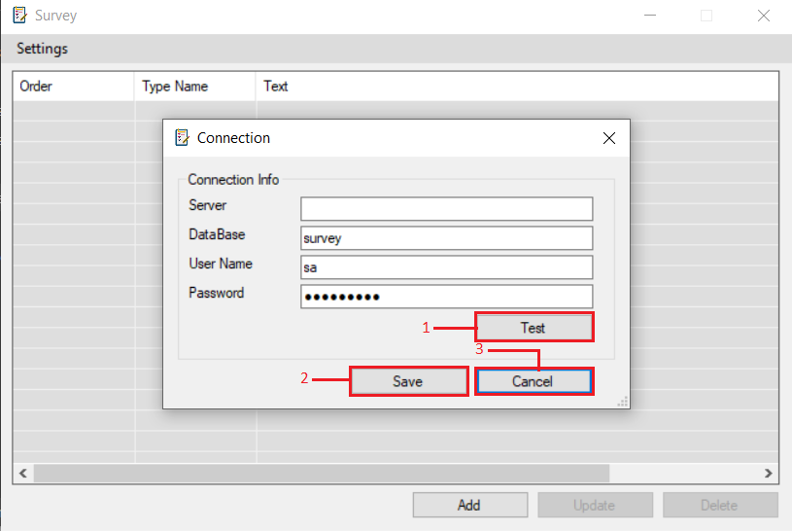

### Test Connection: To ensure the accuracy of the provided data

* **Save** Configuration: If the connection test is successful, the new Configuration will be saved.
  + In case the provided connection data failed during the test, a confirmation popup message will appear, asking you to confirm the operation.

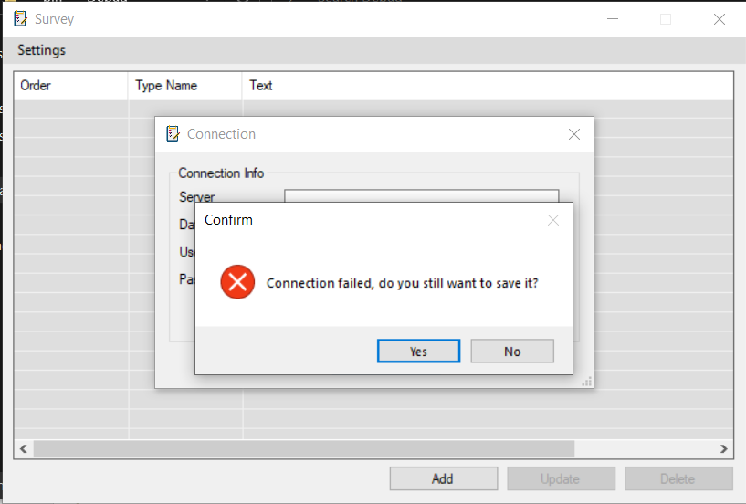

* + If you encounter a "Connection Failed" message, it indicates that the current connection configuration is incorrect.

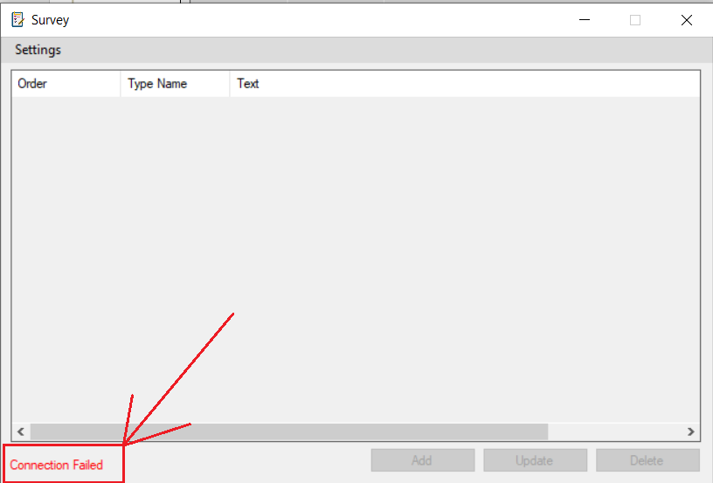

# Conclusion

this guide empowers the System Administrators to manage the app infrastructure effectively. With installation requirements, database setup instructions, and connection configuration insights, the administrators are well-prepared to maintain system efficiency.